**Tutorial 13**

**Greedy algorithm and techniques**

**Instructions**

1. All tutorial sheets will be posted on the Google Classroom.

2. Students are advised to submit tutorial sheets solutions in classroom.

Q1. Find the MST for part a and part b using prim’s and kruskal’s algorithm. Show calculation at every step.

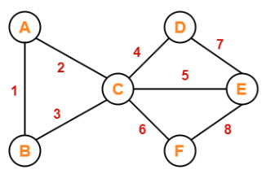 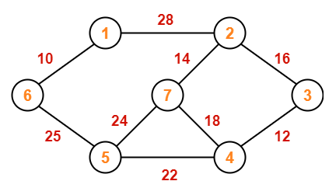

Q2. What is Dijkstra’s Shortest Path Algorithm? Write the algorithm.

Q3. What is knapsack problem, fractional knapsack problem and coinage problem. Explain with suitable examples.

Q4. Find the shortest path using Dijkstra’s Shortest Path Algorithm for the following graph.

